**JAVA – MAVEN – JENKINS – GIT Setup Document**

Set the **JAVA_HOME Environmental variable** (Note: JDK path should be there)

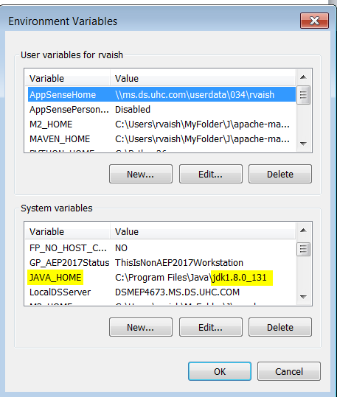

Append “JDK/bin” system location in **Path Environmental Variable.**

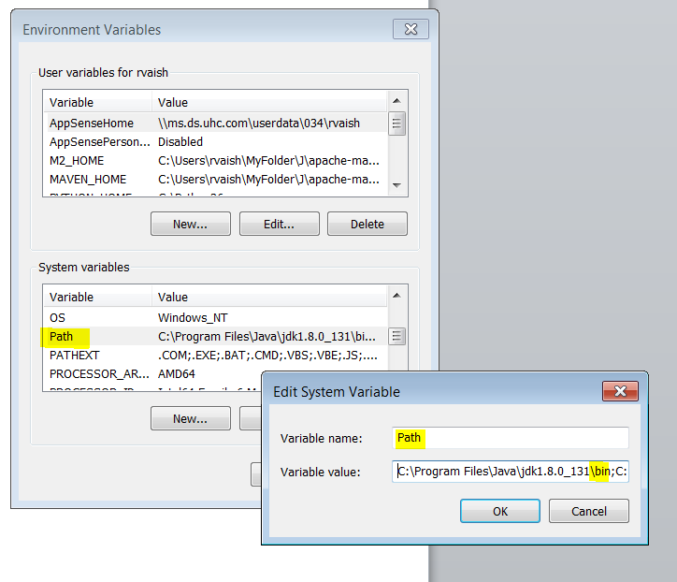

Create new environmental variables as **MAVEN_HOME** and **M2_HOME.** The values will be the system location of apache maven.

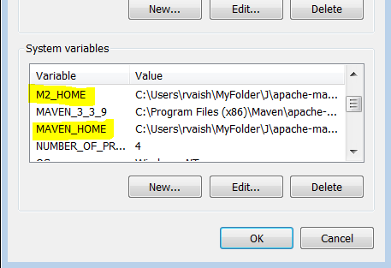

In eclipse make the below setting:

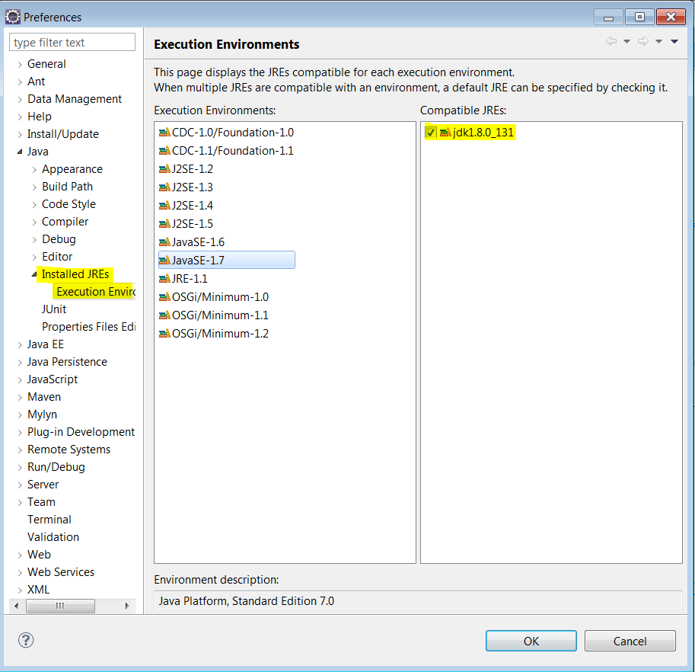

After this, please ensure the below screenshot:

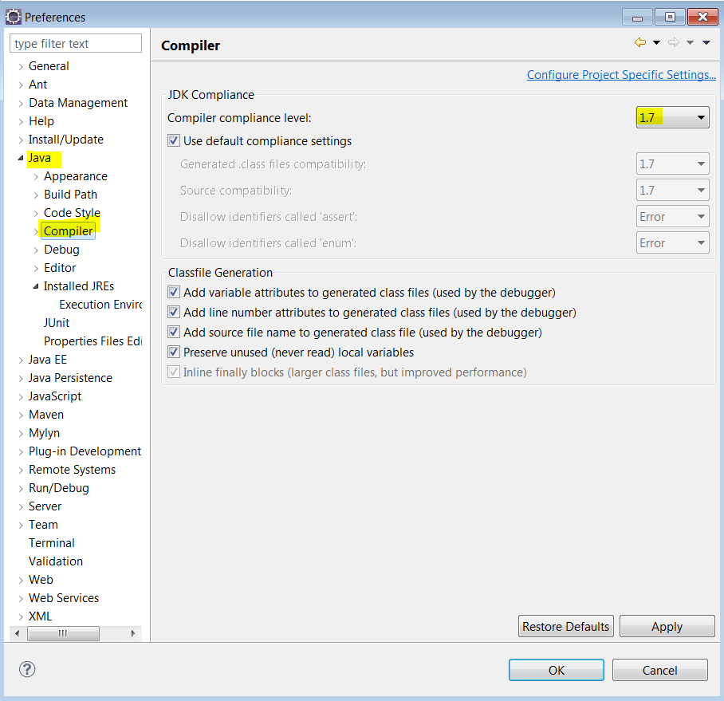

Now download **m2e** (from eclipse market place option) and **eGit (from Install New Software option).**

**eGit steps are as below:**

**eclipse->Help->Install New Software->Add. [The below screenshot appears]**

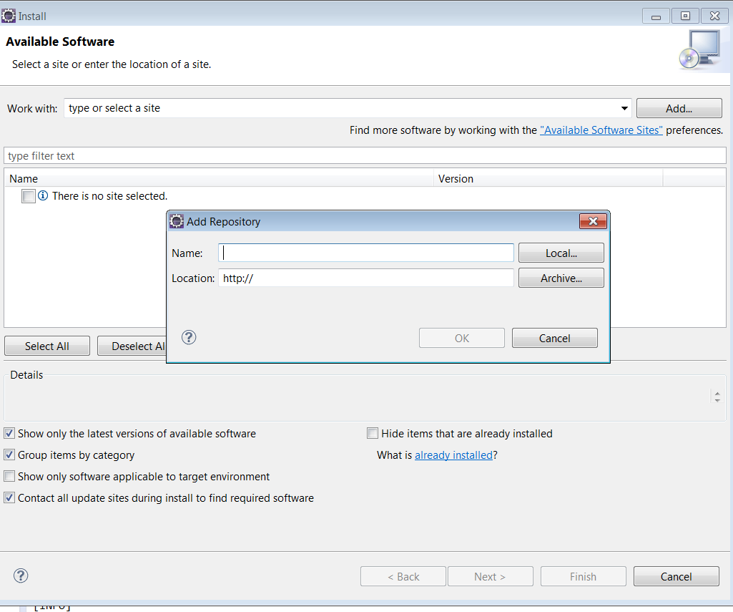

In the **Add Repository** dialog box, enter the following Name and Location.

**Name:** eGit

**Location:** http://download.eclipse.org/egit/updates

Now, in the location C:\Users\<username> create a folder **.m2**

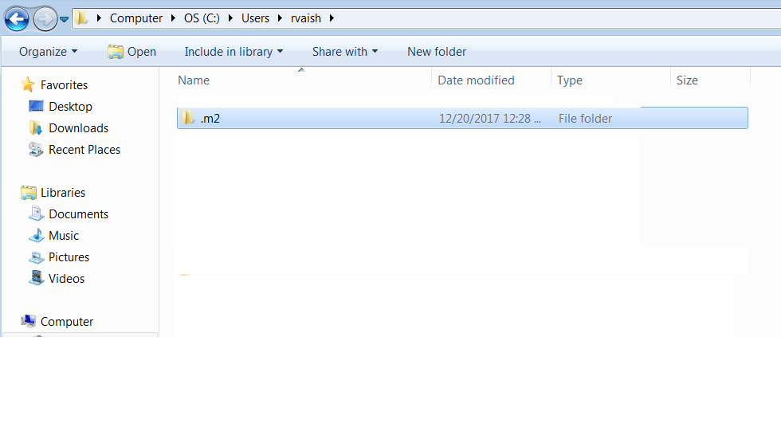

NOTE: If not allowed to create a folder in the above location, create it from command prompt (mkdir .m2)

Now we are ready to create a new Maven Project. Open eclipse - > New -> Project-> Maven Project -> Proceed and finally Finish.

Once the project is made add a demo class (Here in the below example Project_One is the project and ProjectOneClass is the demo class)

Right Click on the Project - > select option Maven Clean, once successfully done, select option Maven Install.

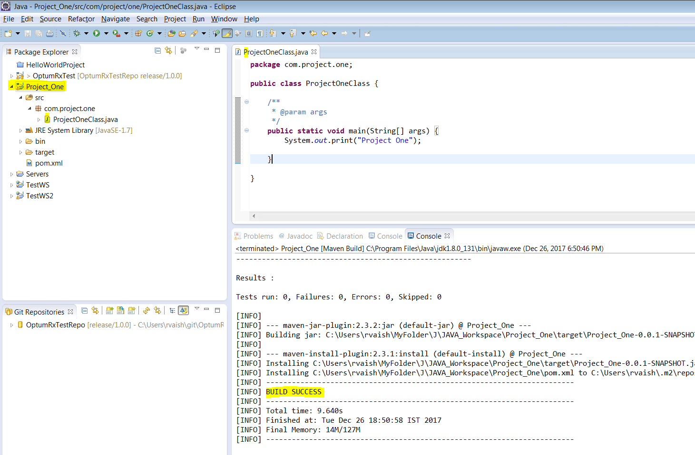

Open Jenkins and login with your employeeId and password

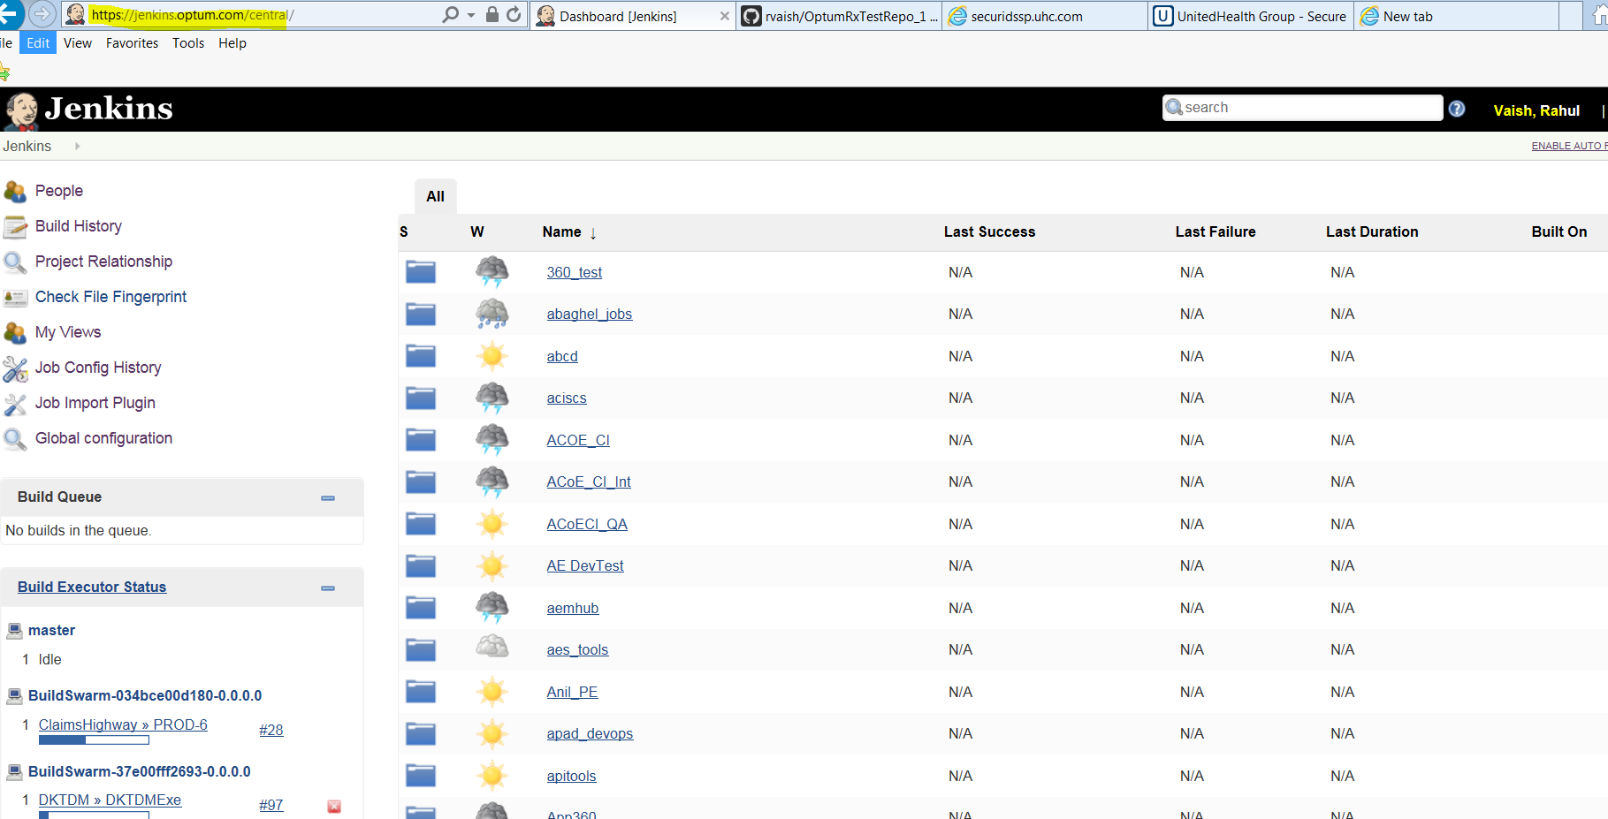

In the search bar, enter the name of your Jenkins Instance. **Example: OptumRxJenkins**: 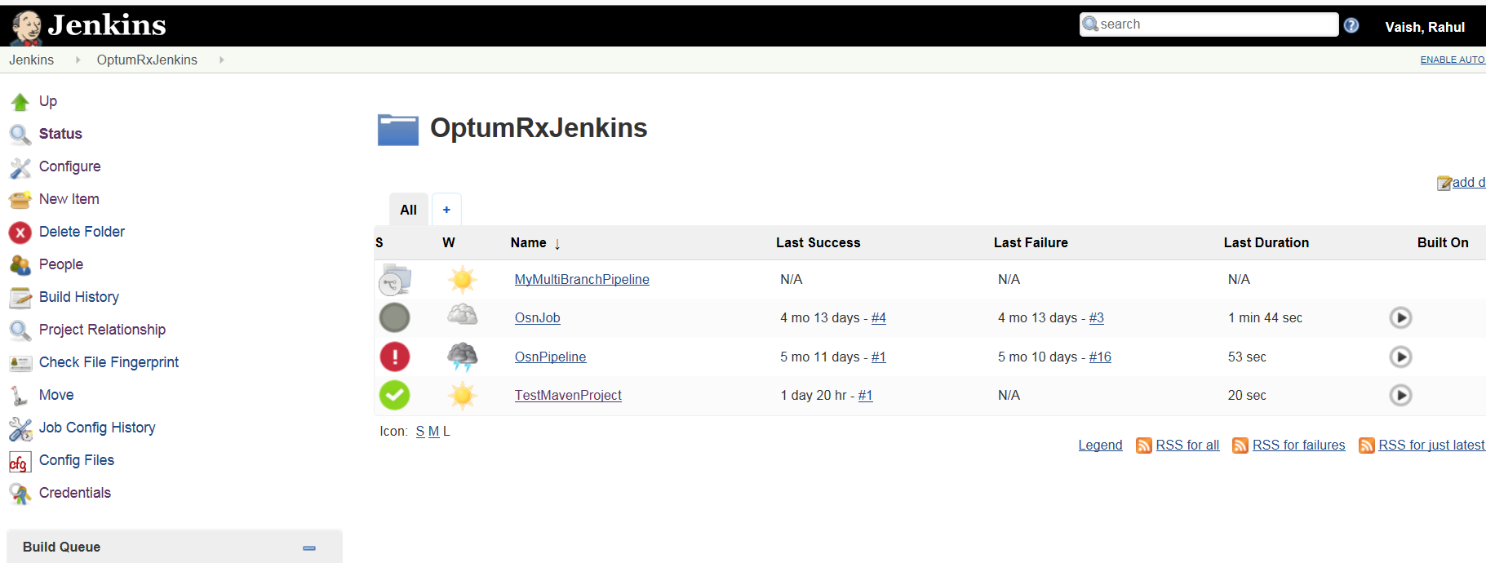

Create a **New Item (which is a JOB)** under the instance : Example TestMavenProject , and click “OK”

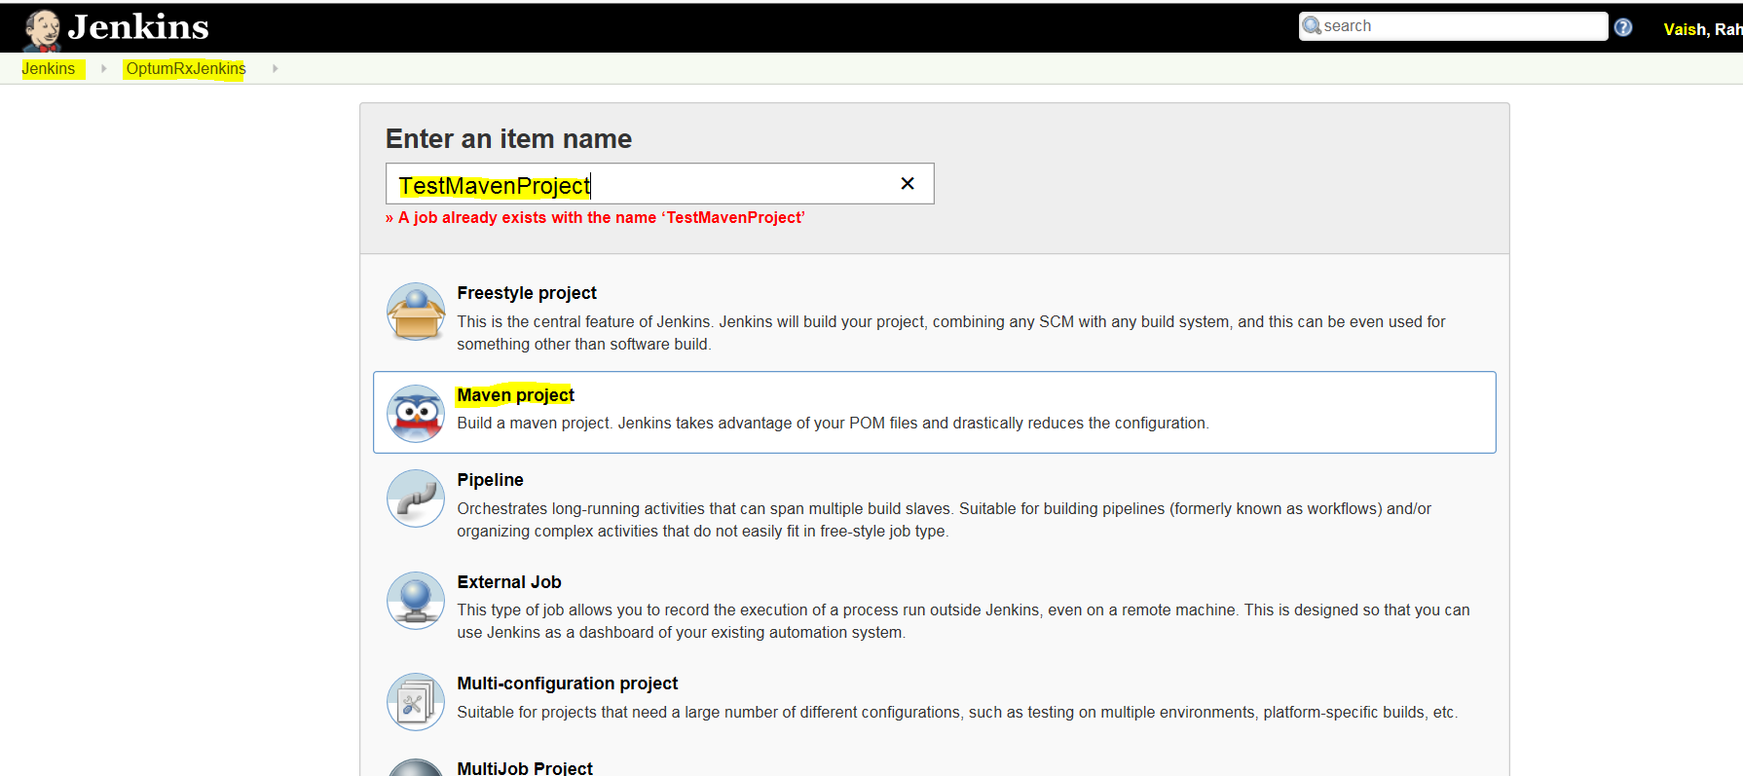

Once done, click on Configure option:

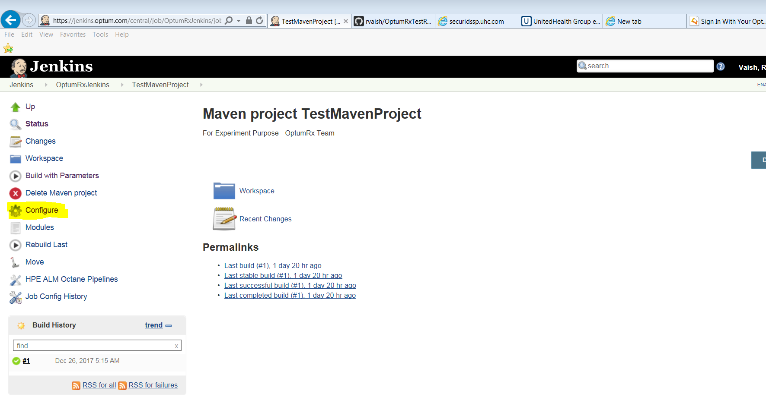

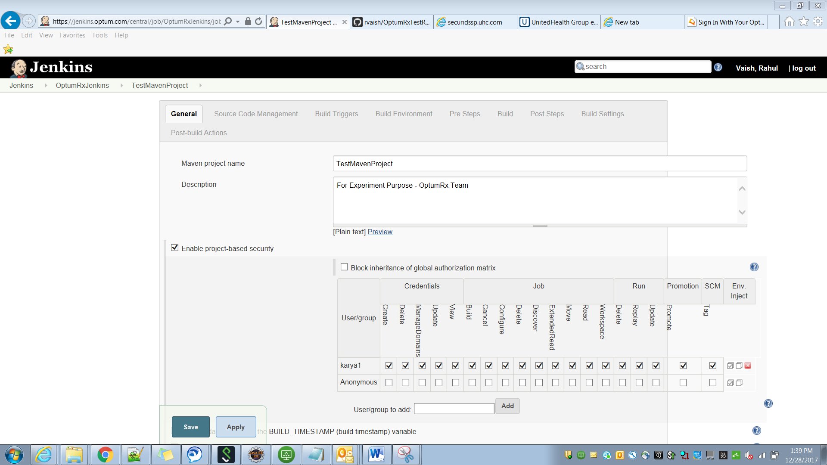

Add the MSID in User/Group field to give access to a team member, and give the necessary access rights -

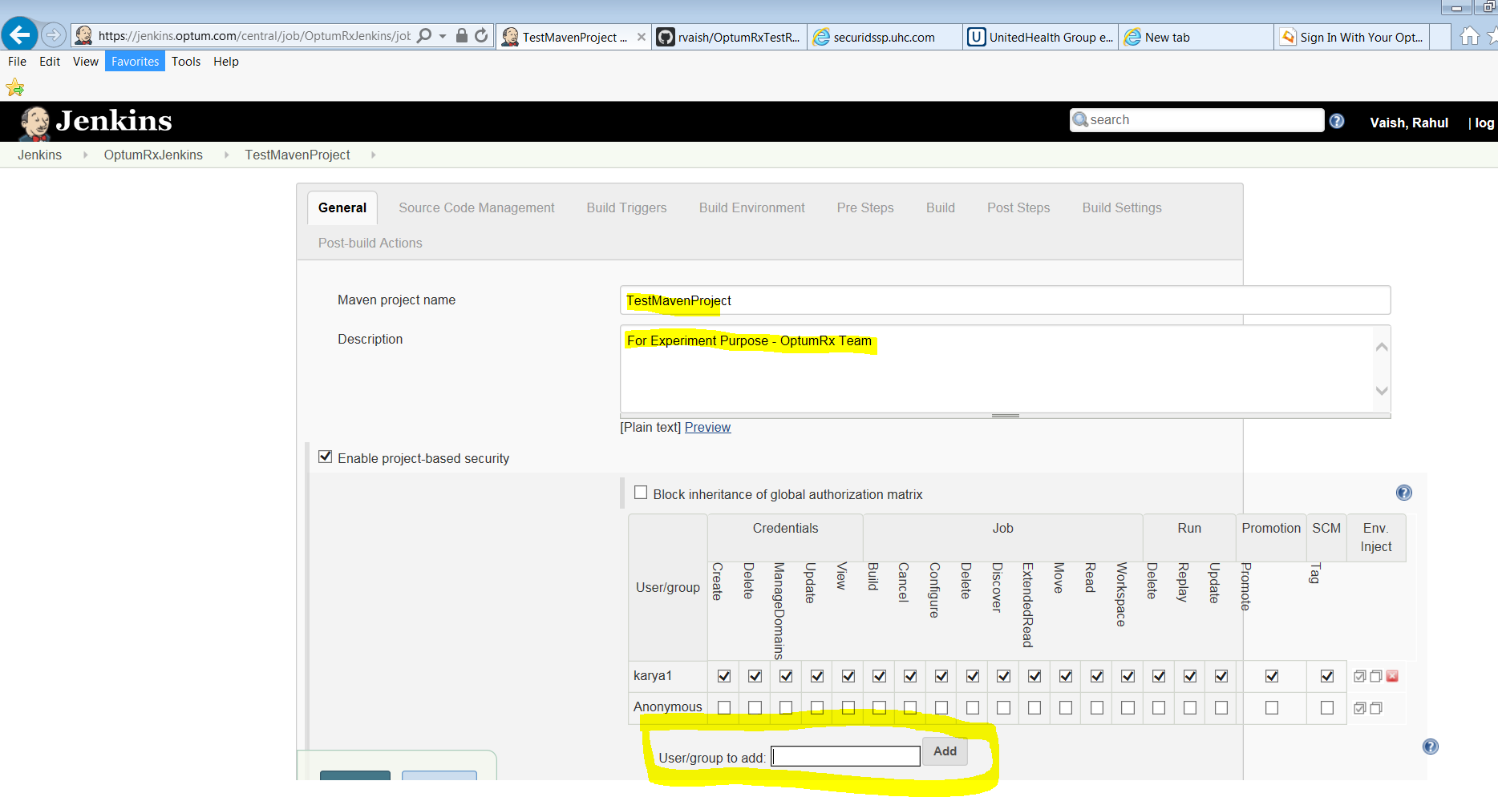

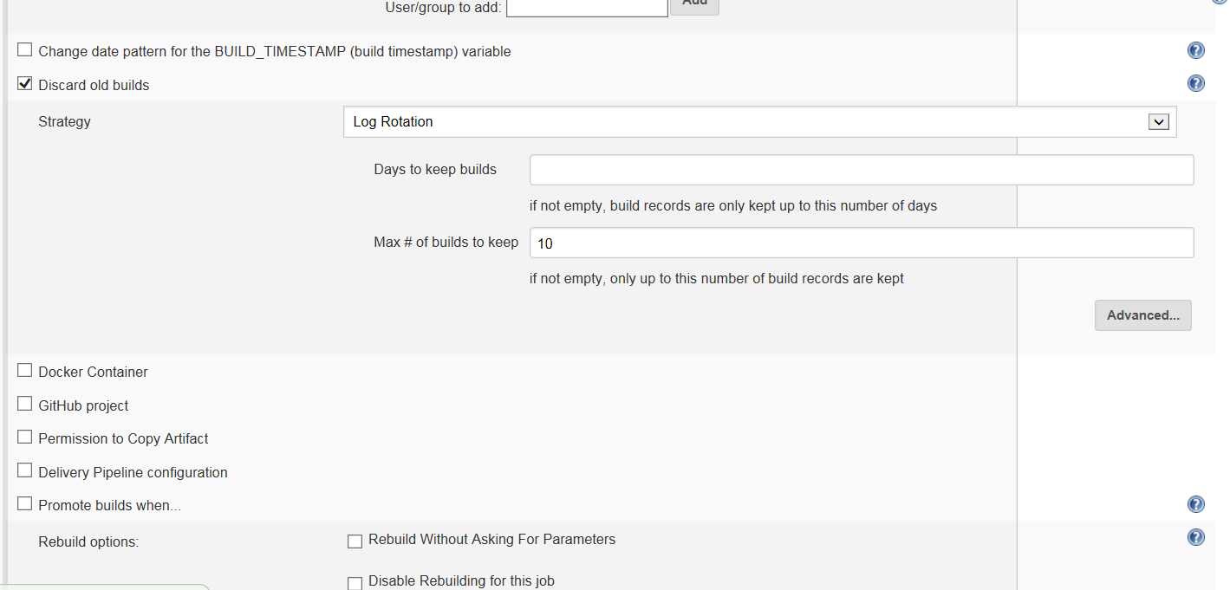

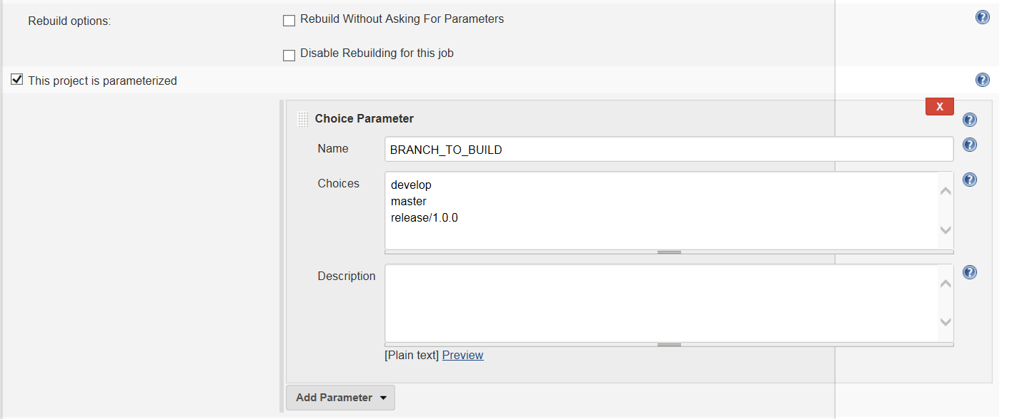

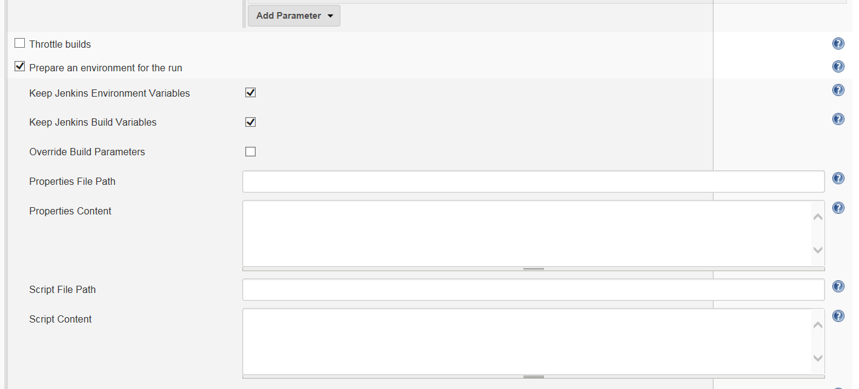

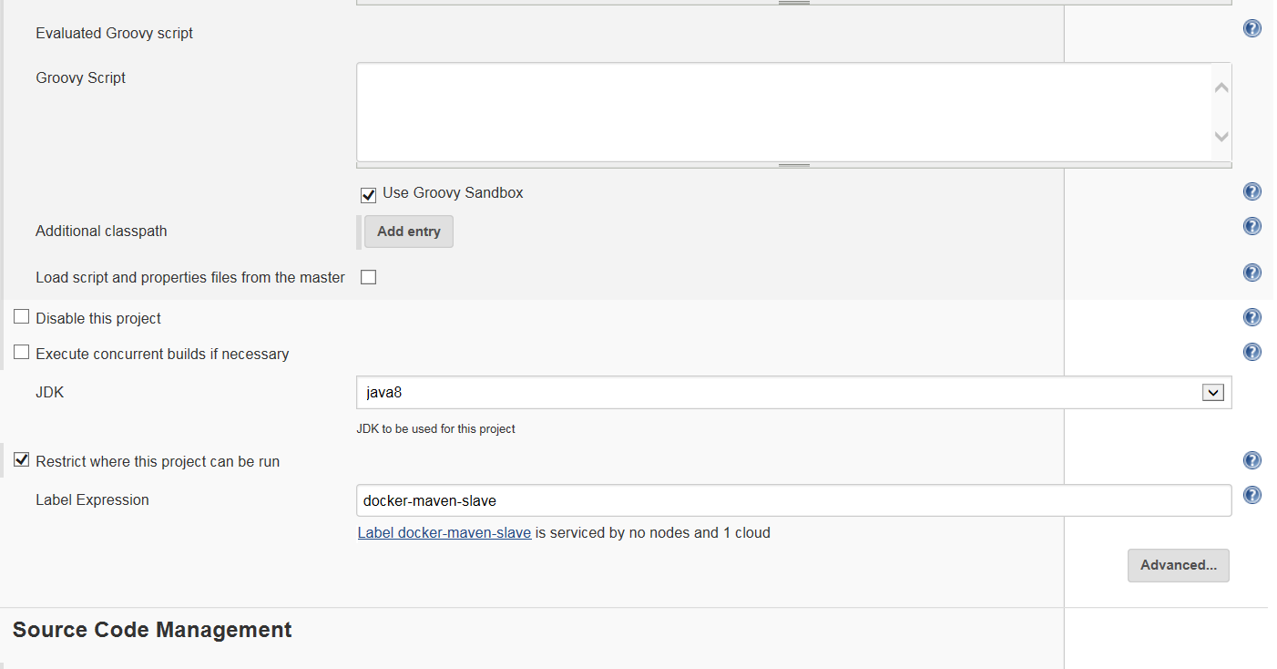

The credentials for our instance needs to be generated from here :

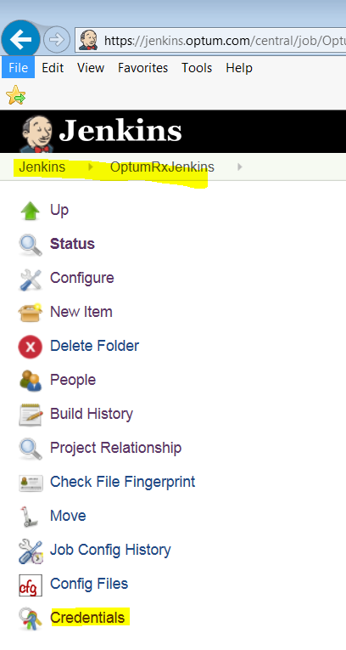 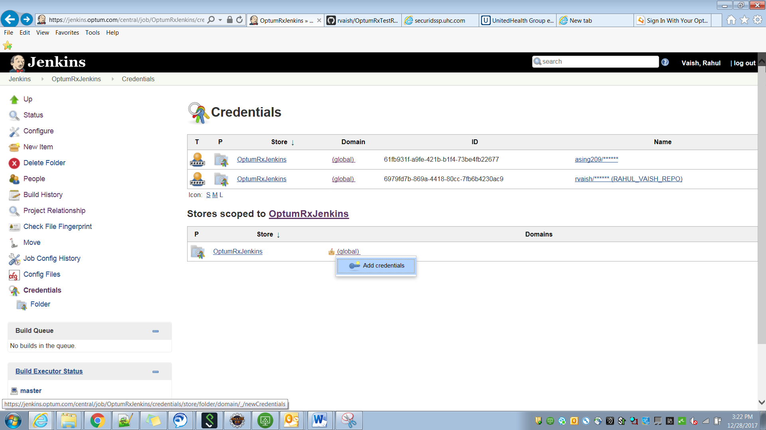

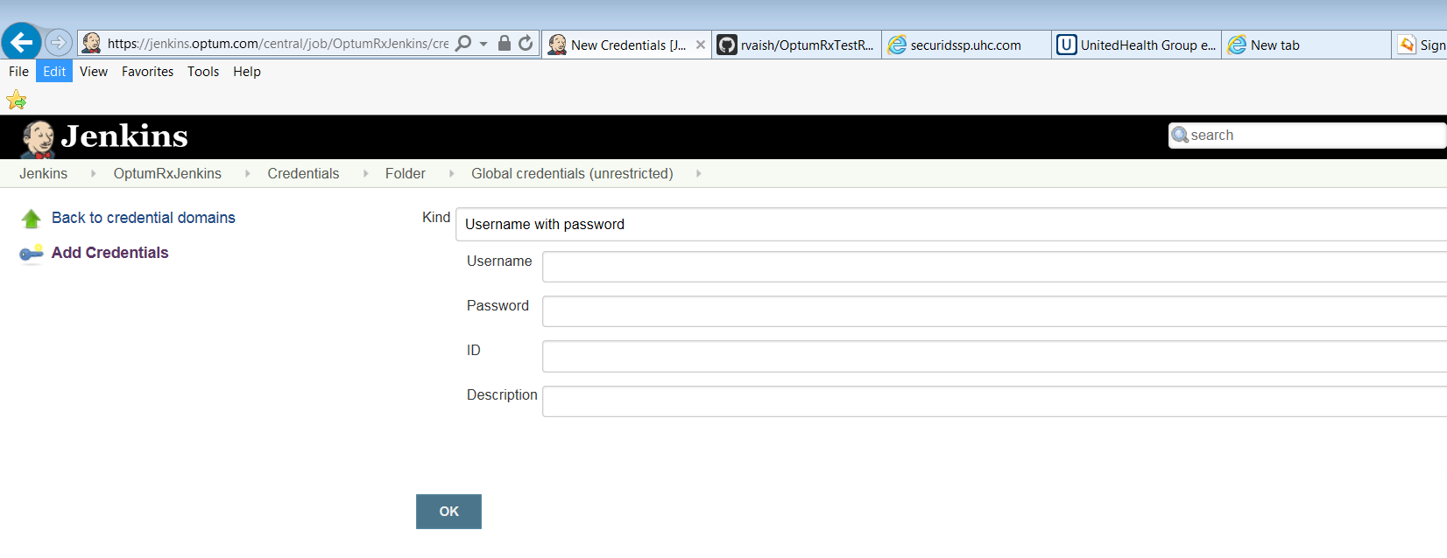

In the Repository URL (below), enter the repository URI. This is mentioned later in the document.

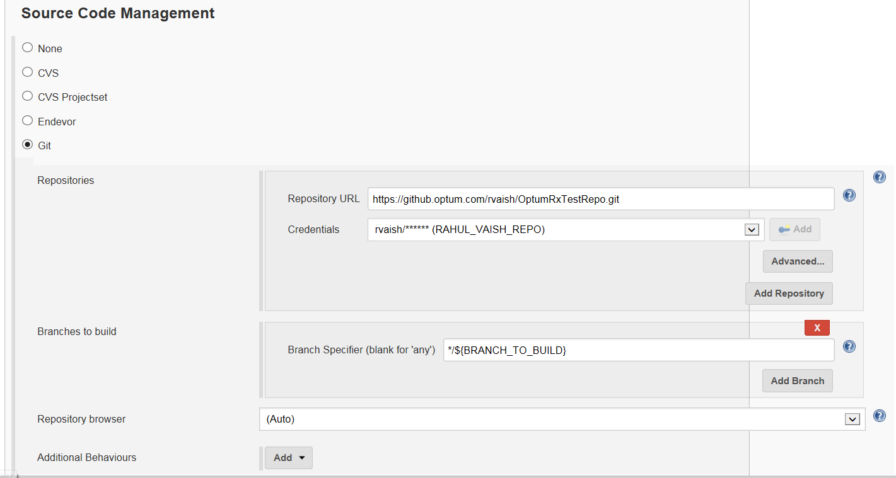

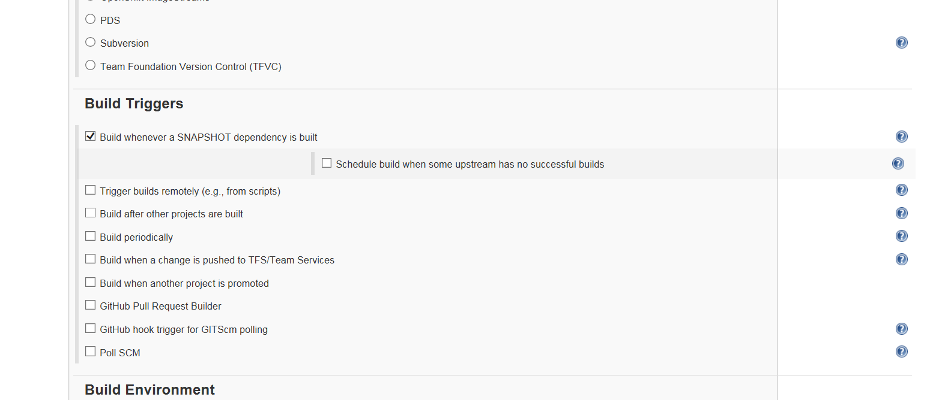

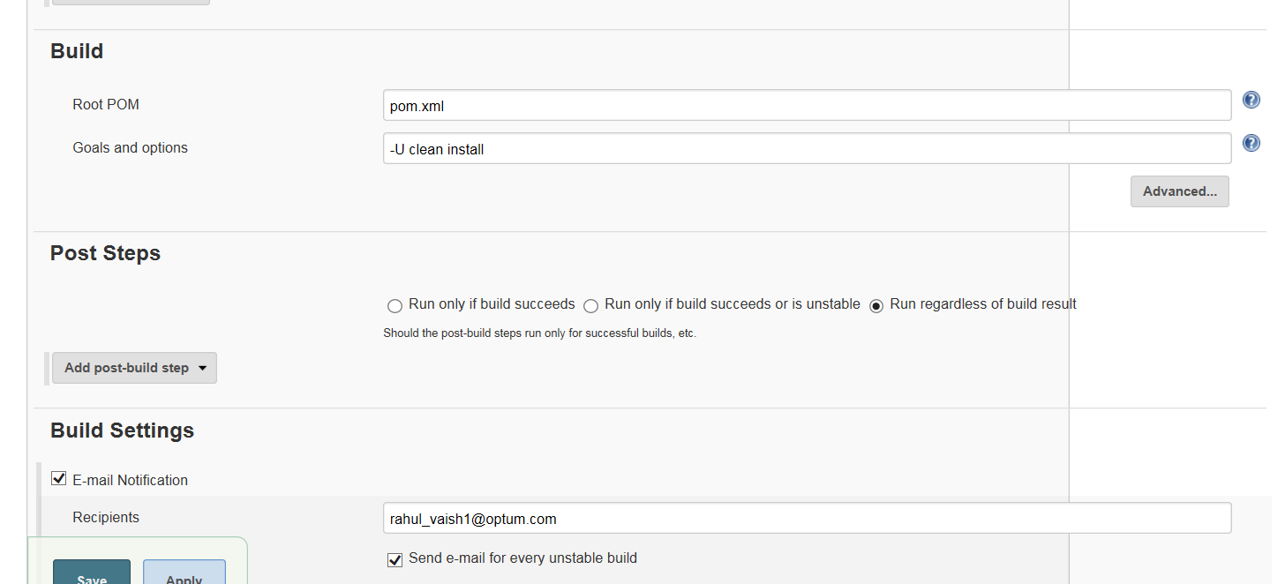

**Save the JENKINS.**

**=====================================================================================**

Open github.optum.com

Login and create a new directory

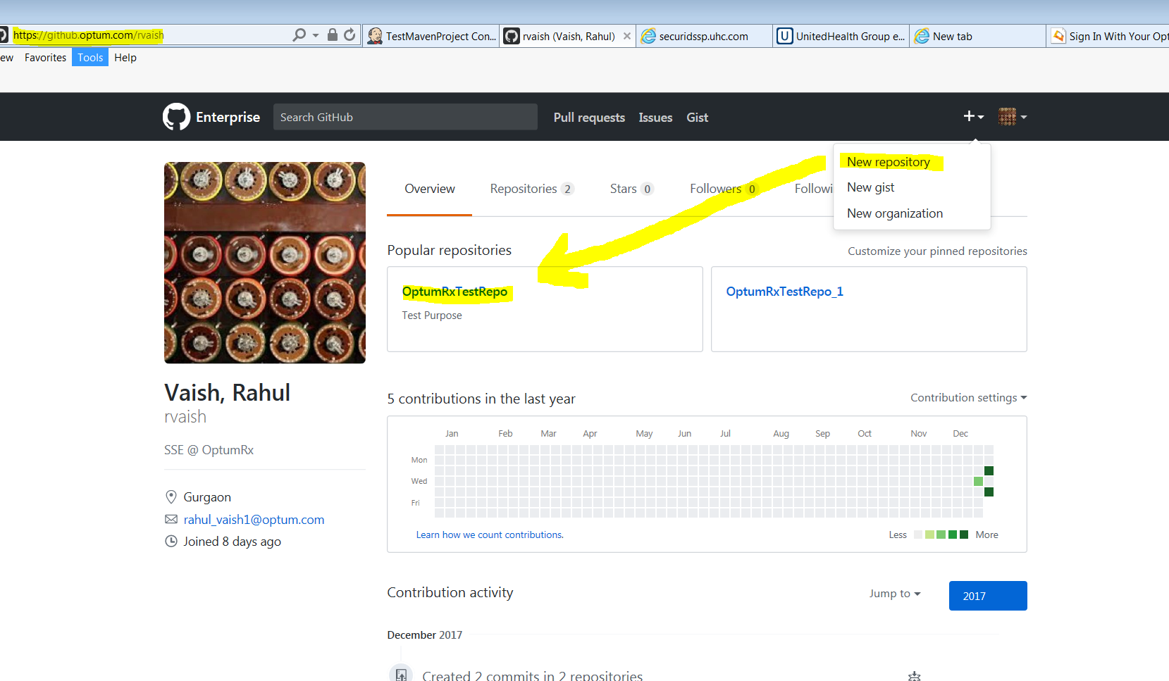

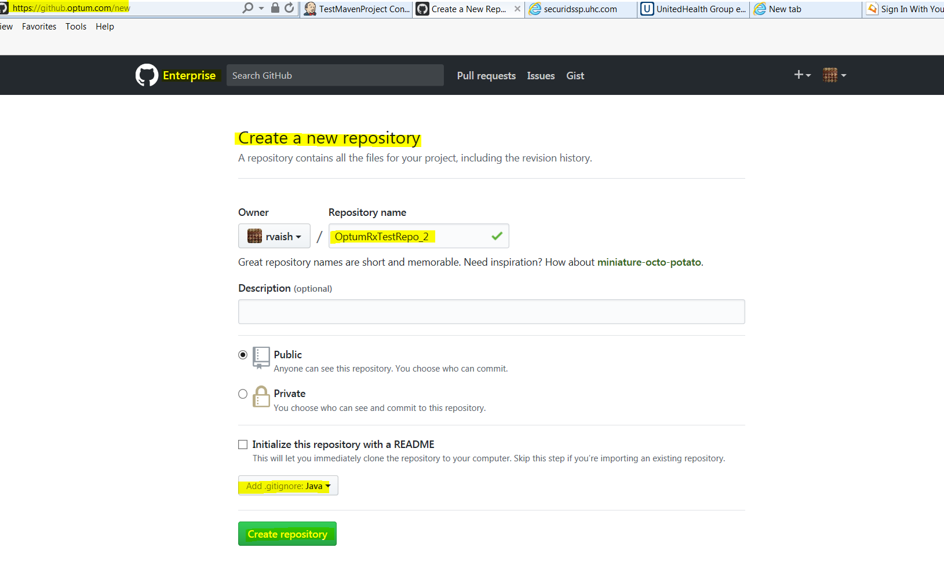

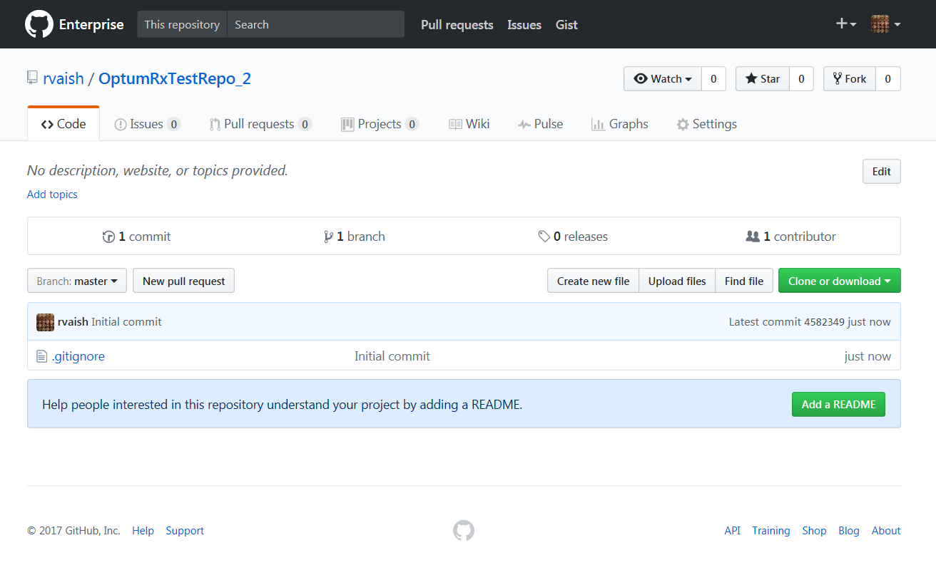

Make a branch

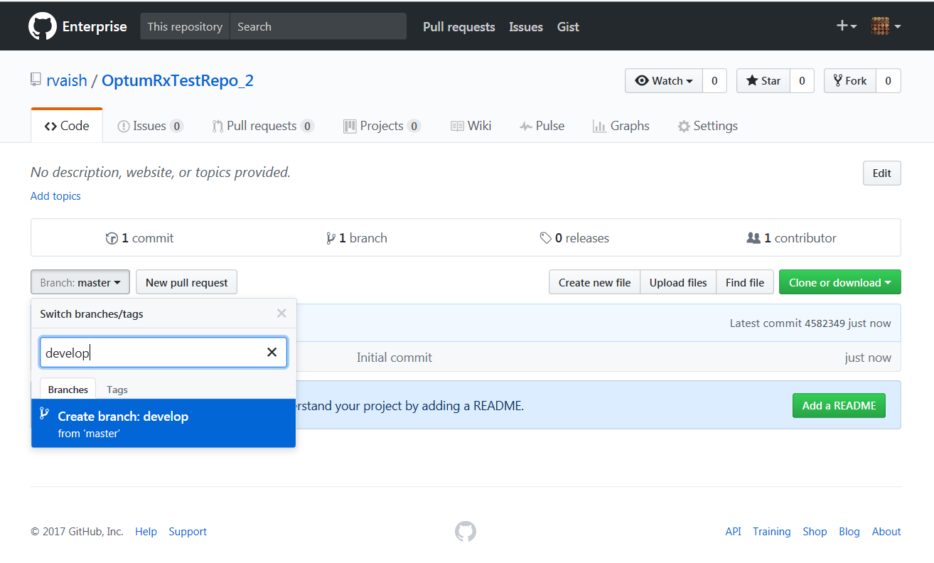

Make another branch

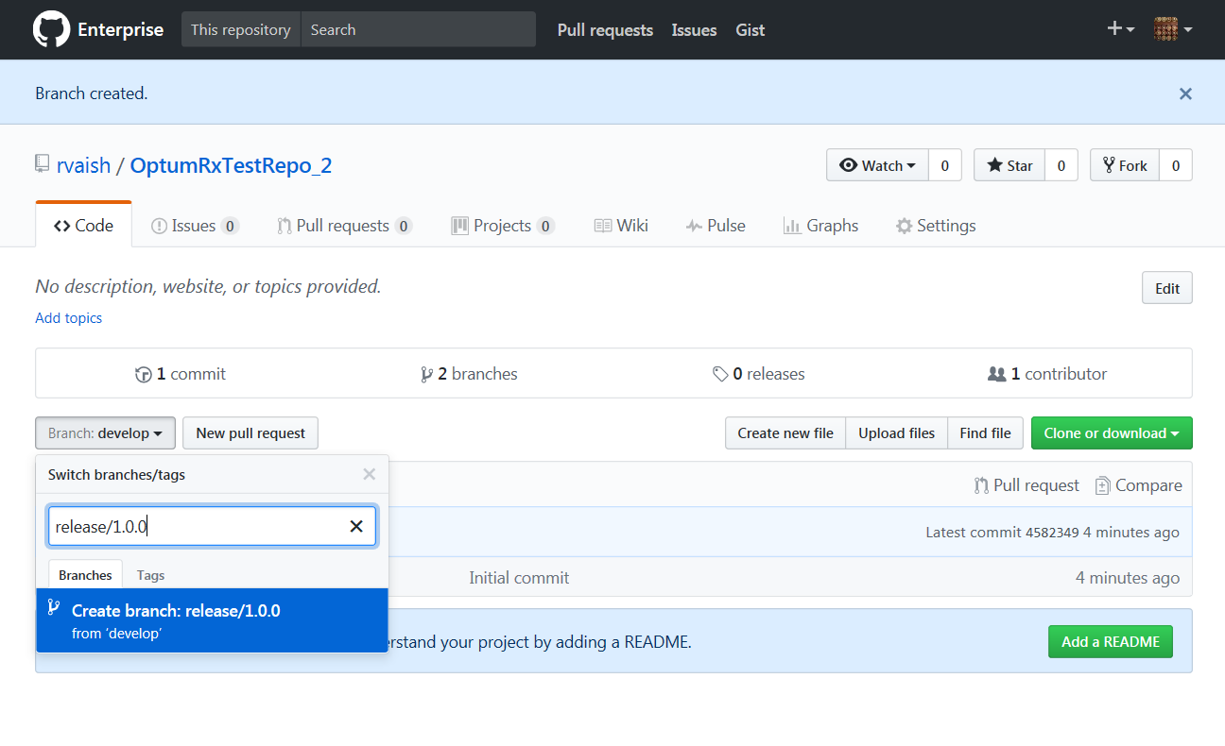

Open eclipse - > Right click on the newly created Maven Project (Here: Project_One with a dummy class ProjectOneClass.java) 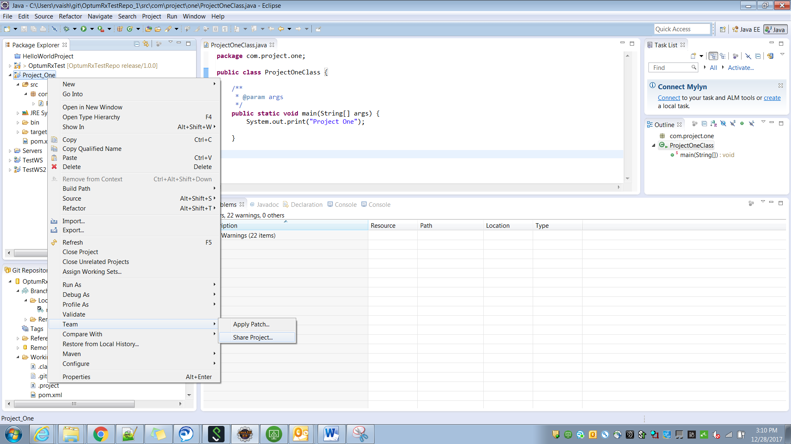 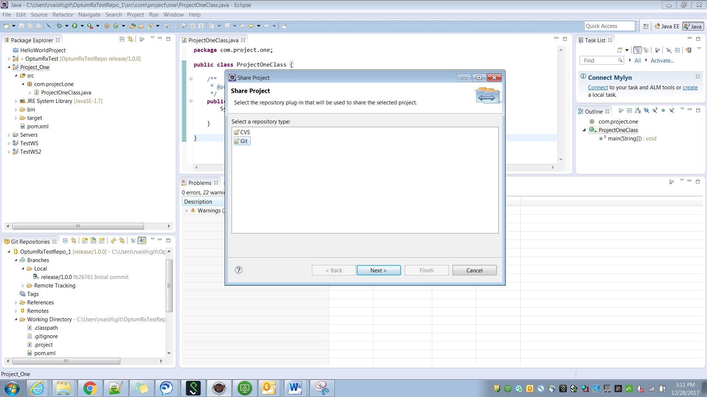

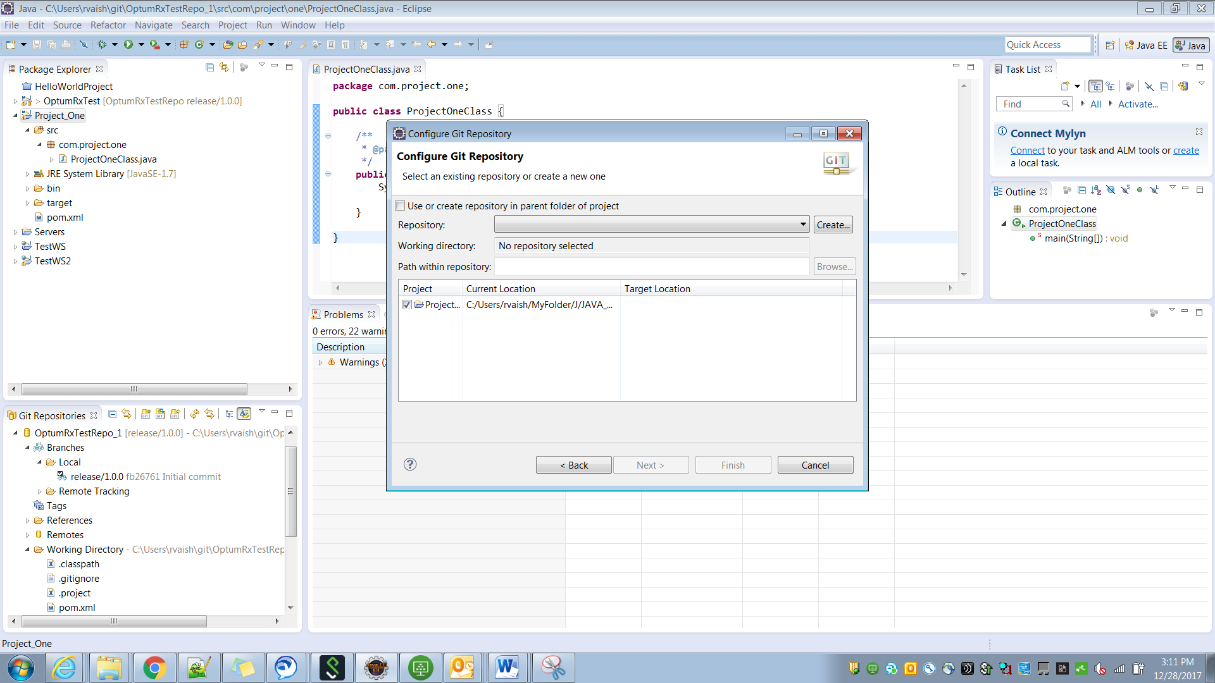

Click on create (we are creating a new local repository)

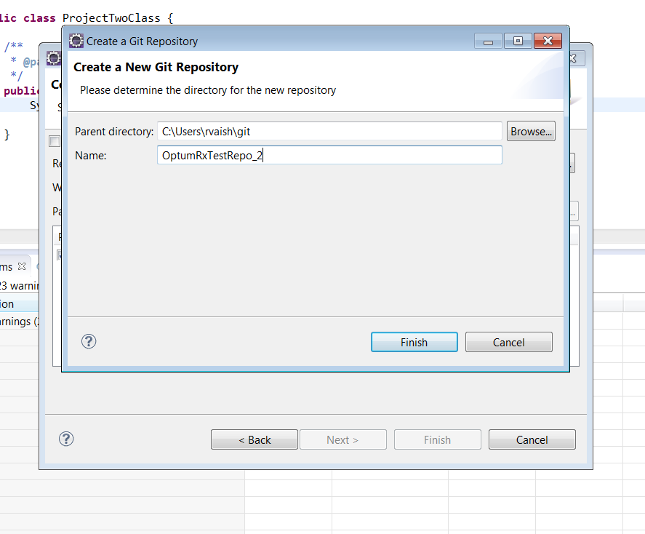

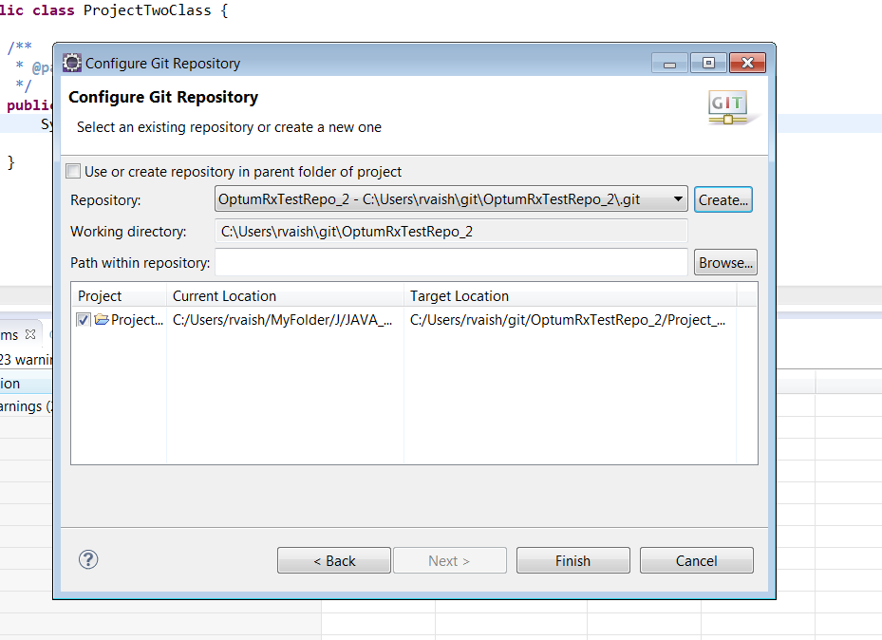

Click on finish

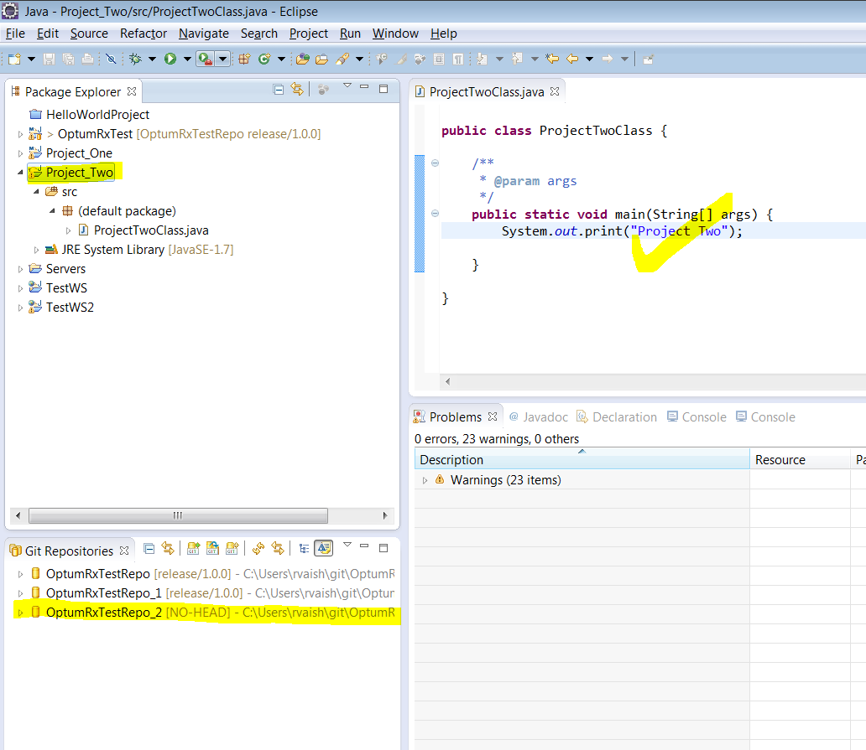

Ensure that appropriate menu is appearing

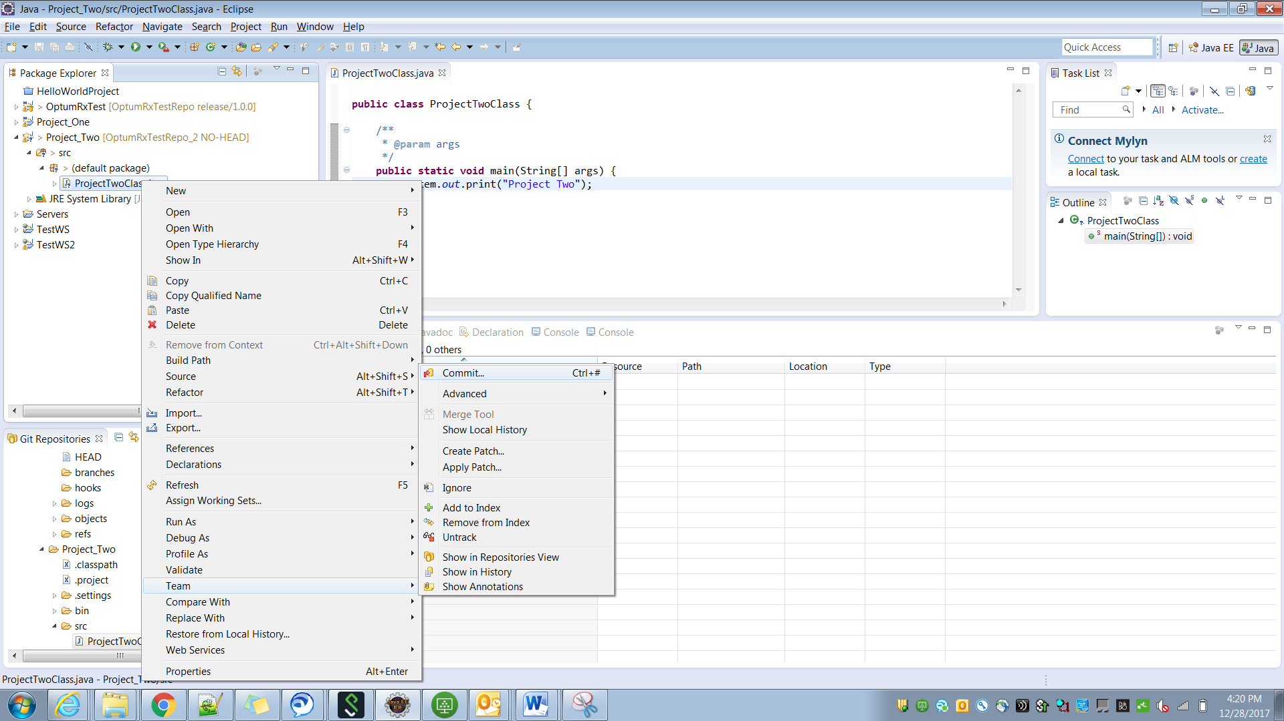

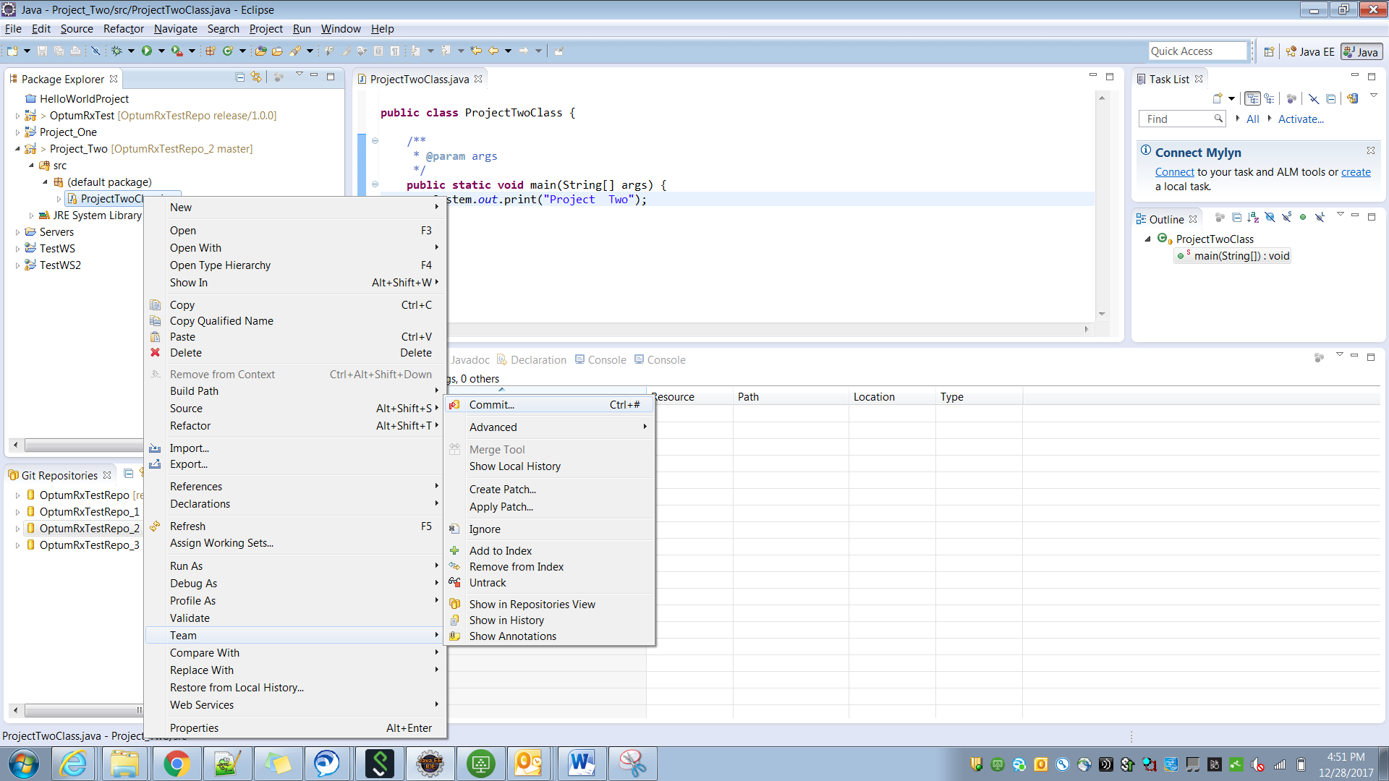

Select all necessary

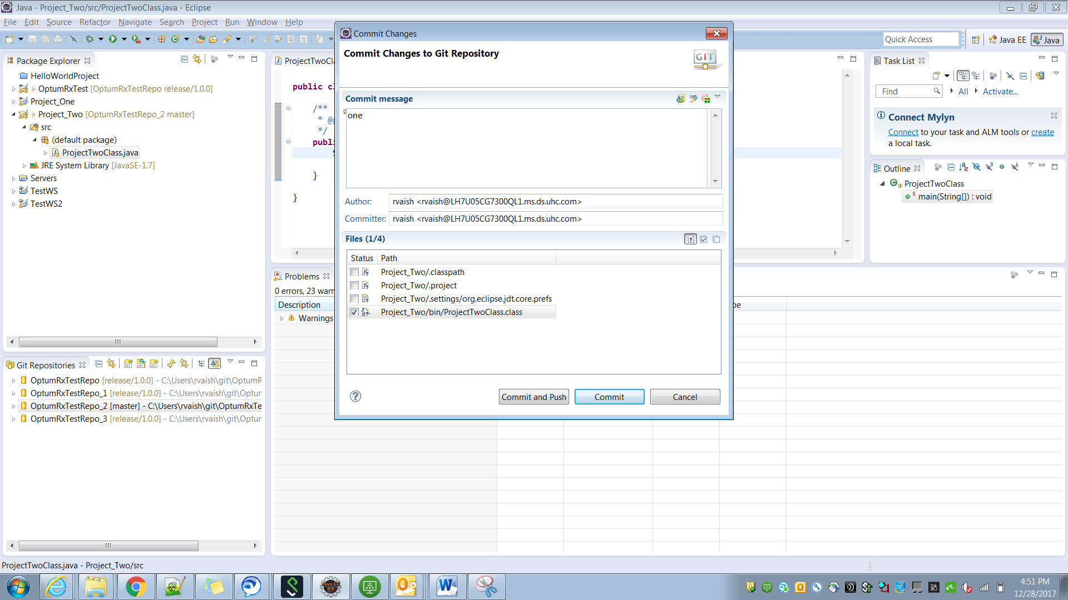

Click on Commit

After that

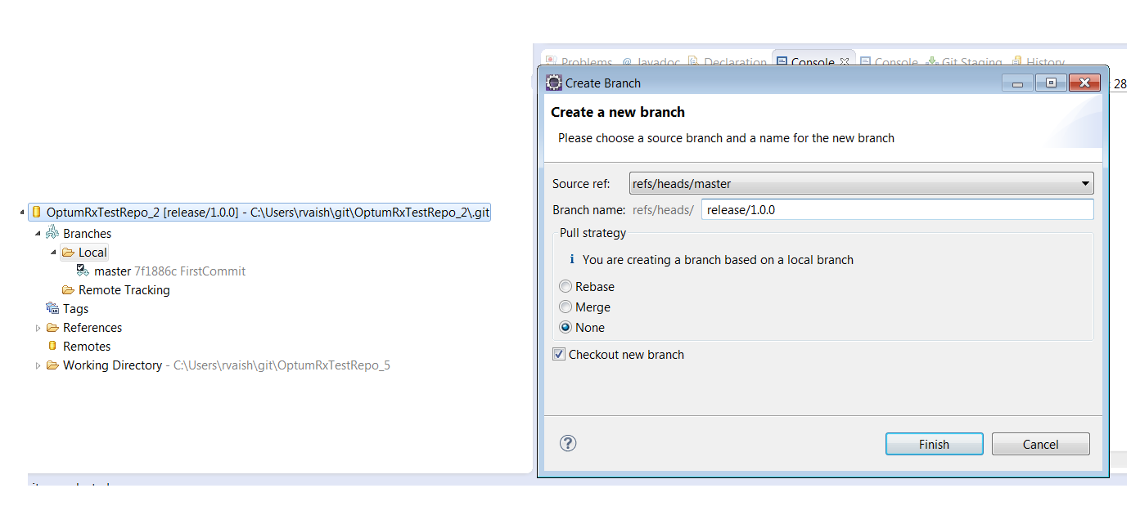

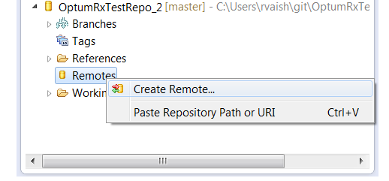

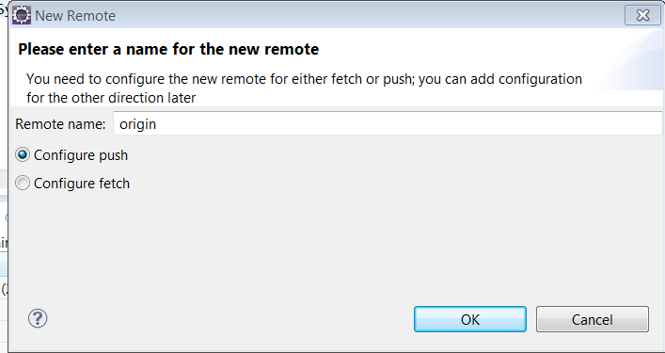

Click on Change

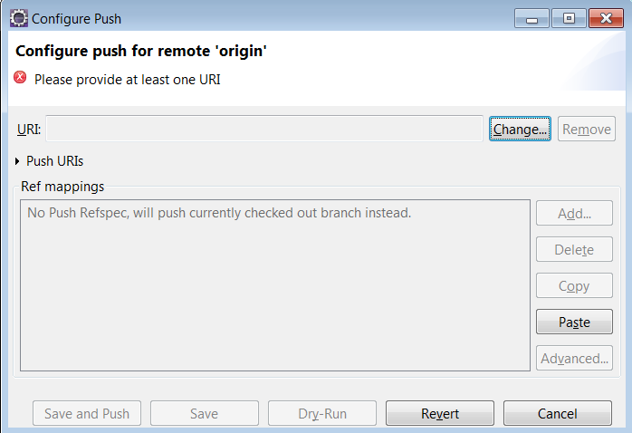

Enter the URI

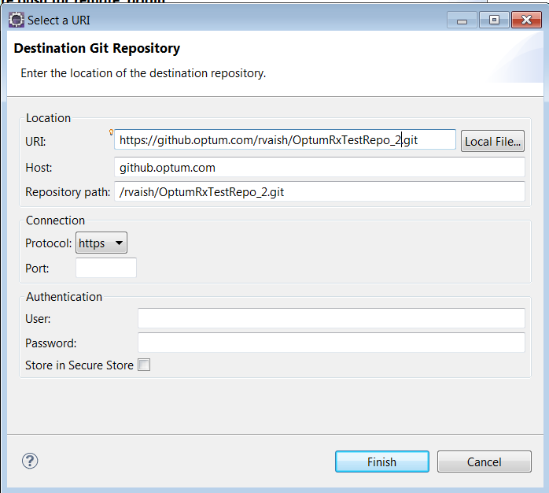

Click finish and then click on advanced button

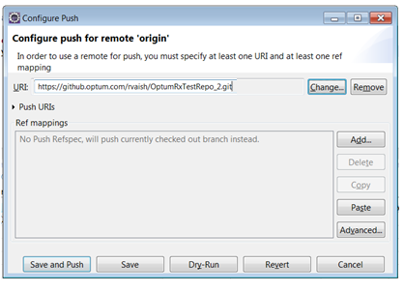

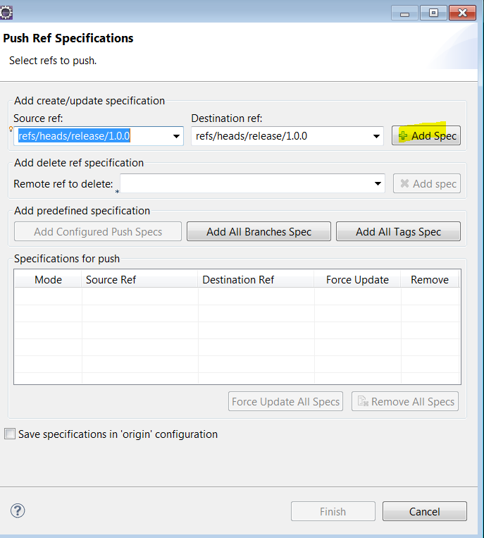

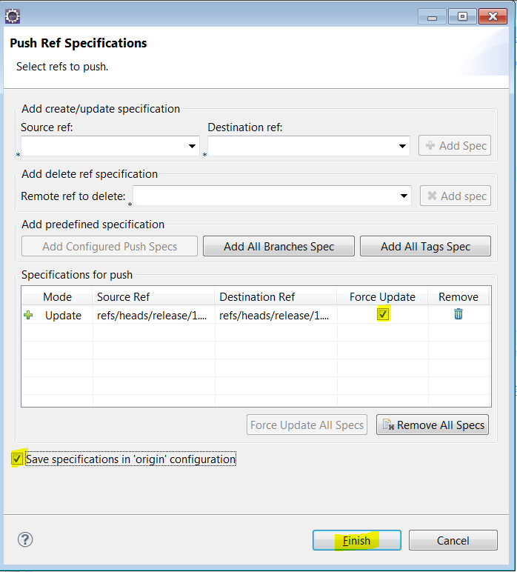

After finish, click on **Save**

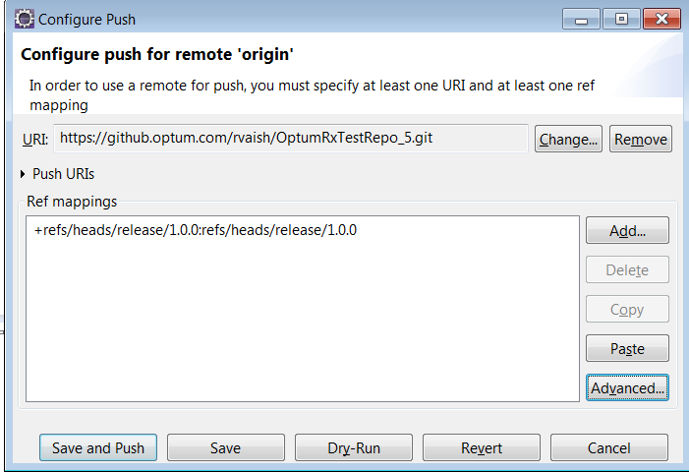

After **save**, notice this

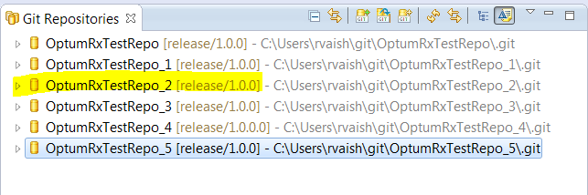

After this, right click on the repository and goto “PUSH” option.

